**Practical No.1**

**Classes and Methods**

**Program 1(a):**

Design an employee class for reading and displaying the employee information, the getInfo() and displayInfo() methods will be used respectively. Where getInfo() will be public method.

**Coding:**

#include<iostream.h>

#include<conio.h>

class employee

{

int id;

char name[20];

public:

void getInfo()

{

cout<<"Enter name and ID of the employee:";

cin>>name>>id;

}

void displayInfo()

{

cout<<"Name of the empoyee:"<<name<<"\nID of the employee:"<<id;

}

};

void main()

{

clrscr();

employee e;

e.getInfo(

);

e.displayInfo();

getch();

}

**Output:**

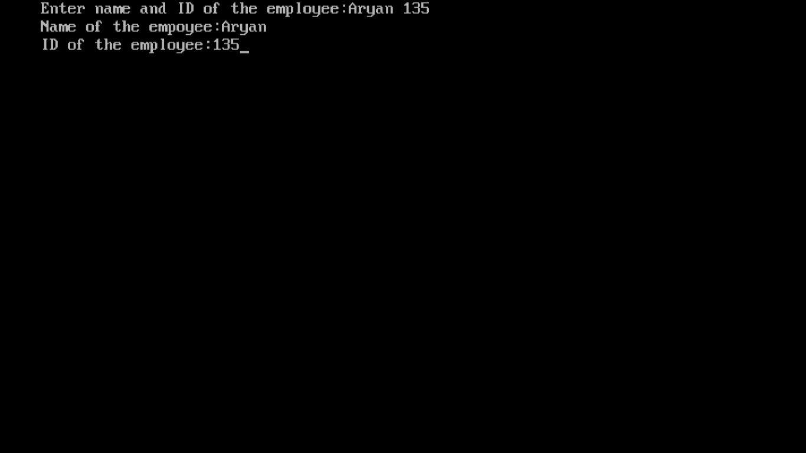

**Program 1(b):**

Design the class student containing getData() and displayData() as two of its methods which will be used for reading and displaying the student information respectively. Where getData() will be public method.

**Coding:**

#include<iostream.h>

#include<conio.h>

class student

{

int roll_number;

char name[20];

public:

void getData()

{

cout<<"Enter name and roll number of the student:";

cin>>name>>roll_number;

}

void displayData()

{

cout<<"Name of the student:"<<name<<"\nRoll number of the student:"<<roll_number;

}

};

void main()

{

clrscr();

student s;

s.getData();

s.displayData();

getch();

}

**Output:**

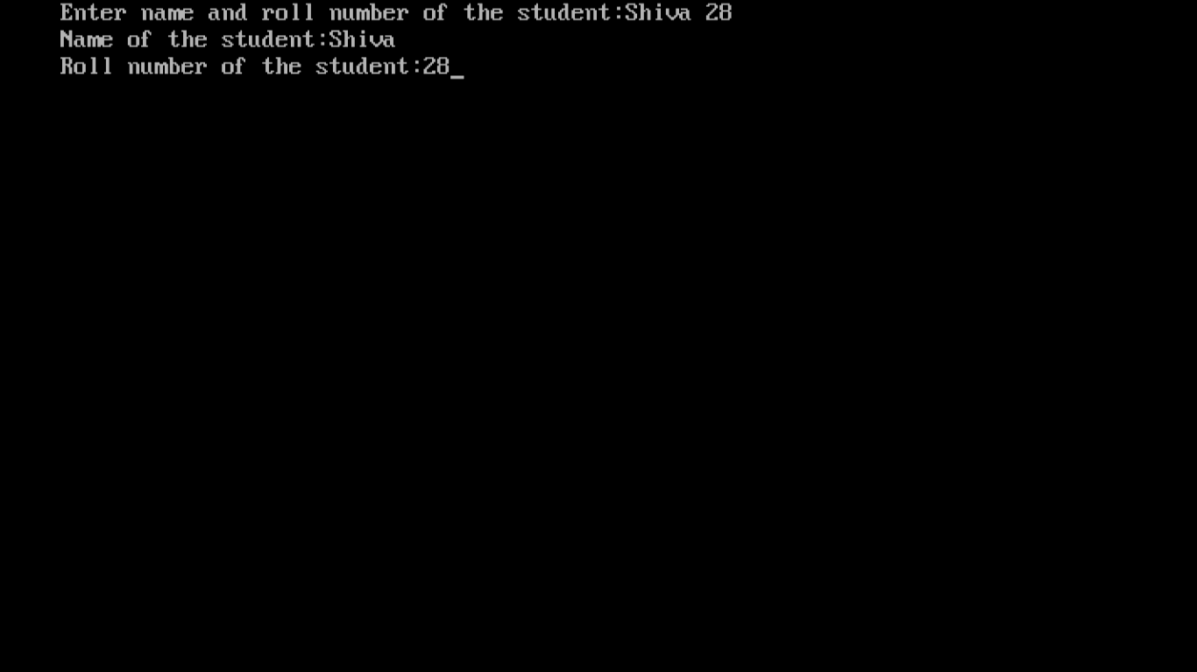

**Program 1(c):**

Design the class Demo which will contain the following methods : readNo(), factorial() for calculating the factorial of a number, reverseNo() will reverse the given number, isPalindrome() will check the given number is palindrome, isArmstrong() which will calculate the given number is Armstrong or not. Where readNo() will be public method.

**Coding:**

#include<iostream.h>

#include<conio.h>

class Demo

{

int no,rev;

public:

void readNo()

{

cout<<"Enter a number:";

cin>>no;

}

int factorial()

{

int i,f=1;

for(i=1;i<=no;i++)

{

f=f*i;

}

return f;

}

int reverseNo()

{

readNo();

int temp=no;

rev=0;

while(temp!=0)

{

rev=rev*10+temp%10;

temp=temp/10;

}

return rev;

}

int isPalindrome()

{

reverseNo();

if(rev==no)

return 1;

else

return 0;

}

int isArmstrong()

{

readNo();

int d,temp=no,sum=0;

while(temp!=0)

{

d=temp%10;

sum+=d*d*d;

temp=temp/10;

}

if(sum==no)

return 1;

else

return 0;

}

};

void main()

{

clrscr();

Demo d;

d.readNo();

cout<<"Factorial="<<d.factorial()<<endl;

cout<<"Reverse of number="<<d.reverseNo()<<endl;

(d.isPalindrome()==1)? cout<<"Palindrome"<<endl:cout<<"Not a Palindrome"<<endl;

(d.isArmstrong()==1)?cout<<"Armstrong Number\n":cout<<"Not an Armstrong Number"<<endl;

getch();

}

**Output:**

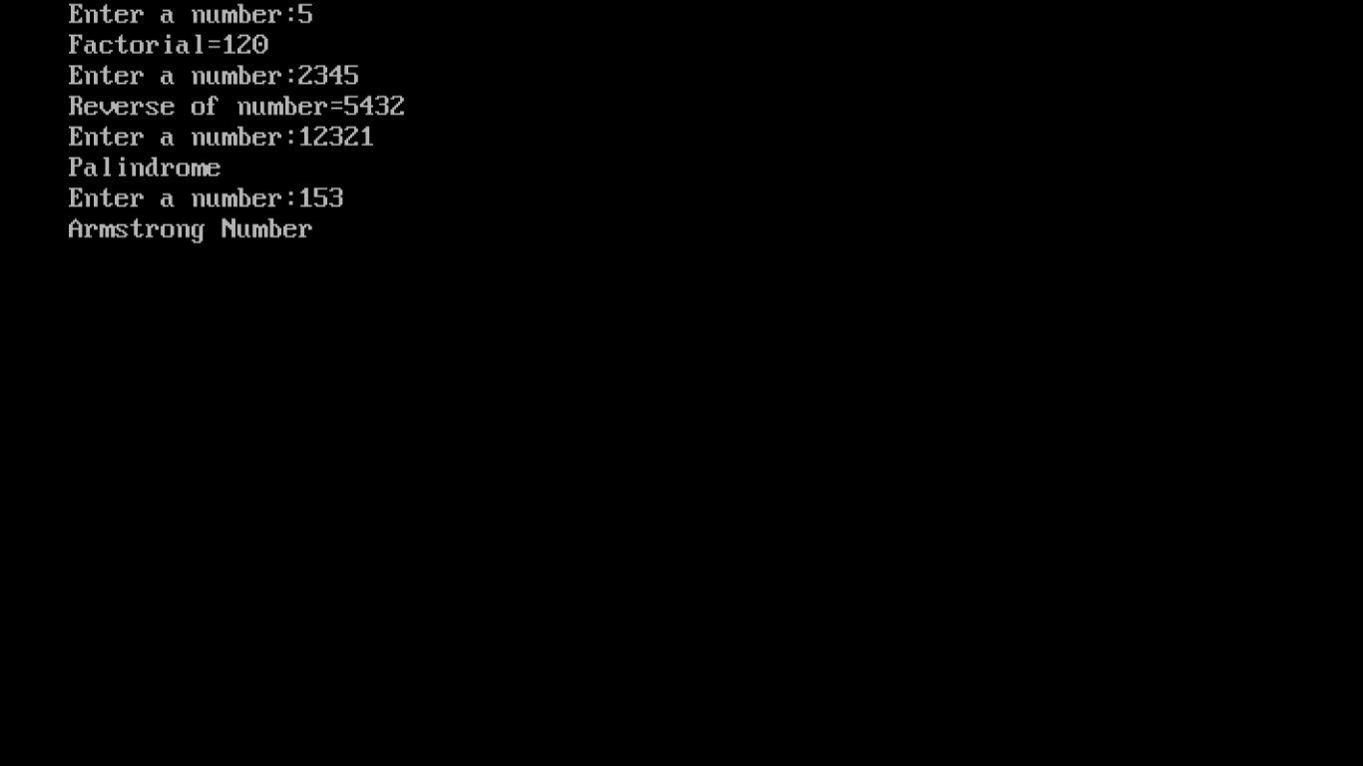

**Program 1(d):**

**Write a program to demonstrate function definition outside class and accessing class members in function definition.**

Example: Write a program to find the area of circle using Object Oriented Programming such that the class circle must have three externally defined member functions namely:

1. read() to accept the radius from the user
2. compute() for calculating area
3. display() for displaying the result

**Coding:**

#include<iostream.h>

#include<conio.h>

class circle

{

float r,a;

public:

void read();

void compute();

void display();

};

void circle::read()

{

cout<<"Enter the radius of the cirle:";

cin>>r;

}

void circle::compute()

{

a=3.14*r*r;

}

void circle::display()

{

cout<<"Area of the circle:"<<a;

}

void main()

{

clrscr();

circle c;

c.read();

c.compute();

c.display();

getch();

}

**Output:**

